
Hep C U Later
Social Media Pack
These social media posts can be used as ‘grab and drop’ posts for organisations who wish to support the global and national aim of eliminating hepatitis C ahead of the World Health Organisation’s 2030 target.
Hep C U Later Posts for Organisations to Use on Social Media

Audiences:
Please use the most appropriate social media posts for your audience – if you would like something specific please contact us on connect.HepCULater@mpft.nhs.uk
Key messages:
Some of the key messages can include:
- Risk factors for hepatitis C
- How to access free at home testing
- Where to access resources and information about hepatitis C
Awareness Weeks/Months:
If you would like to put out social media during awareness weeks the following global and national events can be used to schedule your posts:
- Love your liver month: January
- European Testing Week (Spring): May
- World Hepatitis Day: 28th July
- European Testing Week (Autumn): November
Tag Hep C U Later:
Hep C U Later are on X, Facebook and Linkedin so please tag and follow us!
X - @HepC_U_Later
Facebook - Hep C U Later
LinkedIn - Hep C U Later

The following can be used for both the public and a professional audience:
Post | Graphic
Across England anyone over 18 can now order a free, at home, hepatitis C testing kit using the new NHS national testing portal.  Order a test now by visiting: https://bit.ly/3Uhd5HV  #HepCULater | 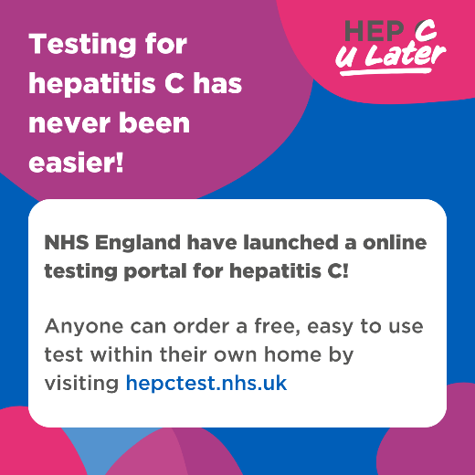
Hepatitis C can cause serious liver damage if left untreated and can lead to cirrhosis or liver cancer. People can have hep C for many years before they start to feel unwell, but early treatment can help to prevent liver damage.  Find out more here - What is hepatitis C? - HEP C U Later  #HepCULater | 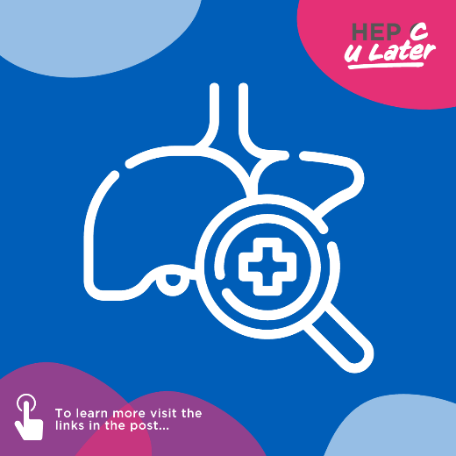
If you have hepatitis C drinking alcohol can increase the damage to your liver.  NHS England advise that if you have hep C you should try to cut down and limit your alcohol intake, read their advice here - https://bit.ly/3SMY7bP  #HepCULater | 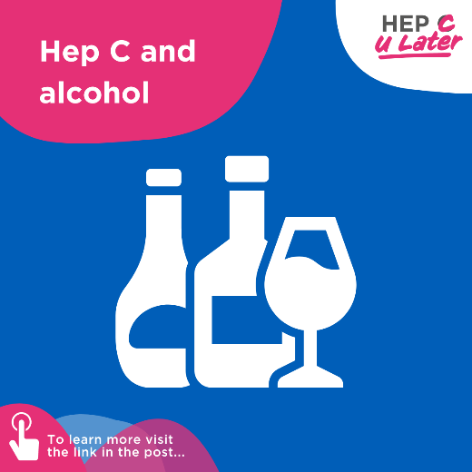
Do you know the risk factors which increase your risk of coming into contact with hepatitis C?  Hepatitis C can be transmitted through blood to blood contact.  Find out more on Hep C U Later’s website - https://bit.ly/4bgaB2y  #HepCULater | 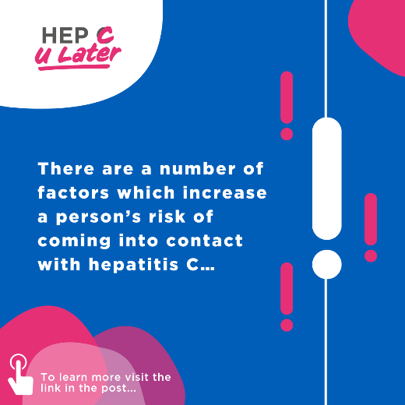
The early symptoms of hepatitis C often go un-noticed, and sometimes people do not have any symptoms at all.  If you think you could have been in contact with hep C order a test today - https://bit.ly/3Uhd5HV  #HepCULater | 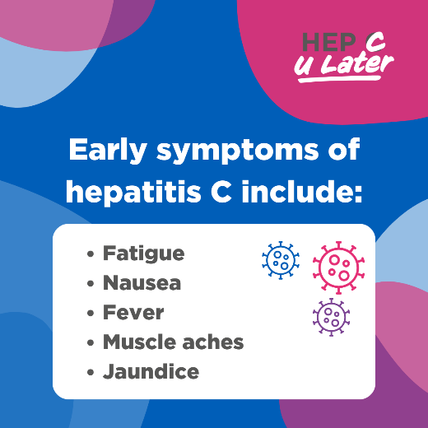

The following posts can also be used for a largely professional audience:
Are you a health and social care professional? Would you like some free CPD Accredited Training?  Click here to access Hep C U Later’s Basic Hepatitis C Awareness online training:  #HepCULater | 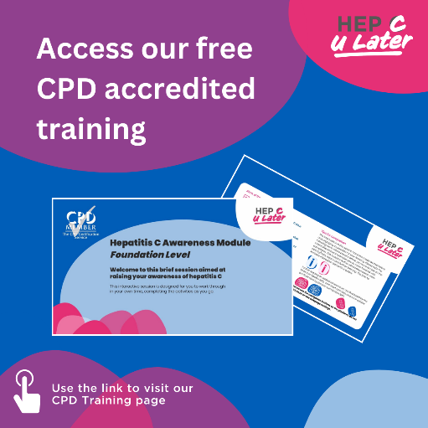
Are you a health and social care professional who would like to know more about hepatitis C?  Hep C U Later have free online and printed resources for professionals:  Order printed materials – connect.HepCULater@moft.nhs.uk  #HepCULater | 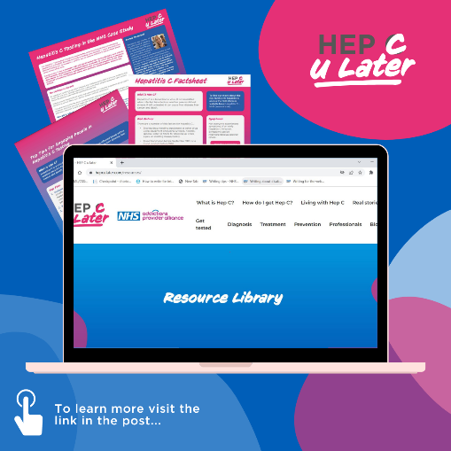
Are you a professional working in Primary Care? Hep C U Later have developed a Primary Care Toolkit for Hepatitis C for everything you need to know.  #HepCULater | 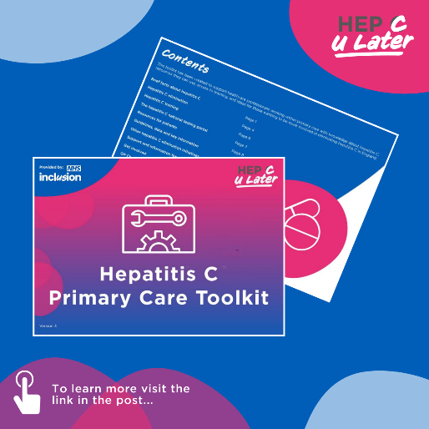
Are you a professional who would like to know more about hepatitis C? You can sign up to the Hep C U Later newsletter to access free resources, podcasts & the latest progress towards eliminating the virus in England  Register to our newsletter (office.com)  #HepCULater | 

Need something else? Contact Connect.HepCULater@mpft.nhs.uk

